How to Write a Screenplay: Script Example & Screenwriting Tips
What is a Screenplay?
In the most basic terms, a screenplay is a 90-120 page document written in Courier 12pt font on 8 1/2" x 11" bright white three-hole punched paper. Wondering why Courier font is used? It's a timing issue. One formatted script page in Courier font equals roughly one minute of screen time. That's why the average page count of a screenplay should come in between 90 and 120 pages. Comedies tend to be on the shorter side (90 pages, or 1 ½ hours) while Dramas run longer (120 pages, or 2 hours).
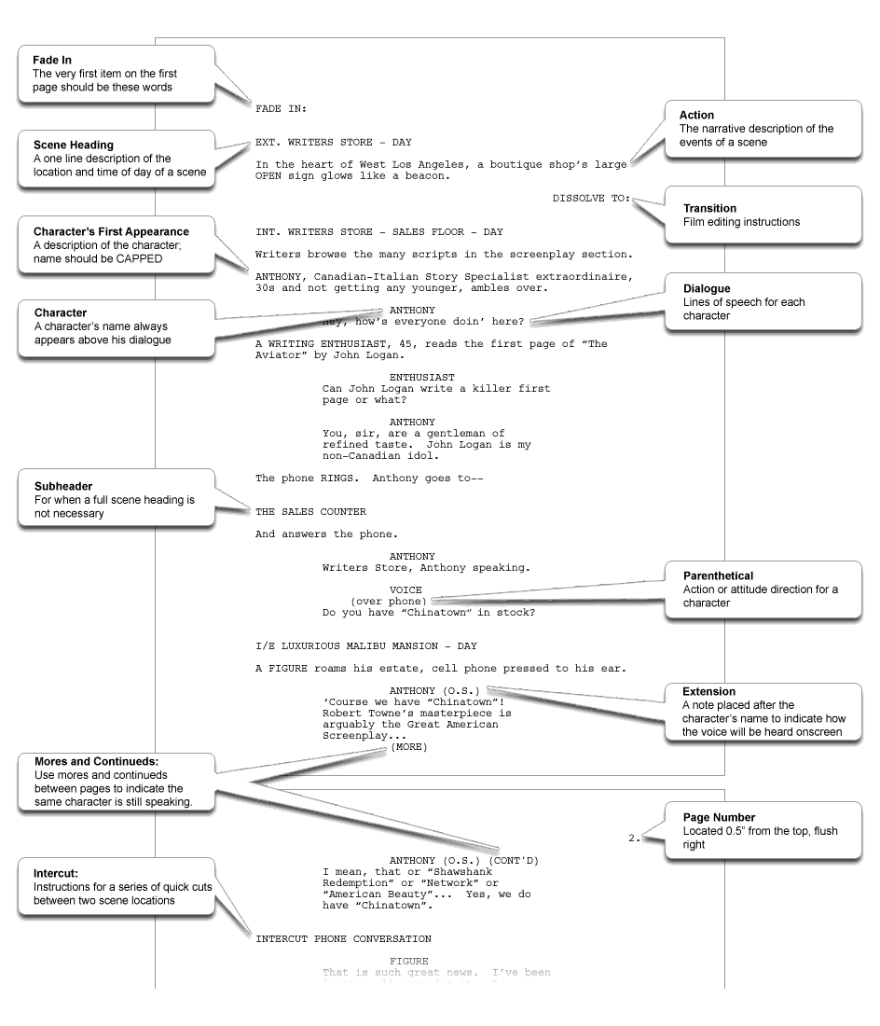
A screenplay can be an original piece, or based on a true story or previously written piece, like a novel, stage play or newspaper article. At its heart, a screenplay is a blueprint for the film it will one day become.
For example, it's crucial to remember that film is primarily a visual medium. As a screenwriter, you must show what's happening in a story, rather than tell. A 2-page inner monologue may work well for a novel, but is the kiss of death in a script. The very nature of screenwriting is based on how to show a story on a screen, and pivotal moments can be conveyed through something as simple as a look on an actor's face. Let's take a look at what a screenplay's structure looks like.
The First Page of a Screenplay
The very first item on the first page should be the words FADE IN:
Scene Heading
A scene heading is a one-line description of the location and time of day of a scene, also known as a "slugline." It should always be in CAPS.
Example: EXT. WRITERS STORE - DAY reveals that the action takes place outside The Writers Store during the daytime.
Subheader
When a new scene heading is not necessary, but some distinction needs to be made in the action, you can use a subheader. But be sure to use these sparingly, as a script full of subheaders is generally frowned upon. A good example is when there are a series of quick cuts between two locations, you would use the term INTERCUT and the scene locations.
Action
The narrative description of the events of a scene, written in the present tense. Also less commonly known as direction, visual exposition, blackstuff, description or scene direction.
Remember - only things that can be seen and heard should be included in the action.
Character
When a character is introduced, his or her name should be capitalized within the action. For example: The door opens and in walks LIAM, a thirty-something hipster with attitude to spare.
A character's name is CAPPED and always listed above his lines of dialogue. Minor characters may be listed without names, for example "TAXI DRIVER" or "CUSTOMER."

Dialogue
Lines of speech for each character. Dialogue format is used anytime a character is heard speaking, even for off-screen and voice-overs.
Parenthetical
A parenthetical is direction for the character, that is either attitude or action-oriented.
Extension
Placed after the character's name, in parentheses. An abbreviated technical note placed after the character's name to indicate how the voice will be heard onscreen, for example, if the character is speaking as a voice-over, it would appear as LIAM (V.O.).
Transition
Transitions are film editing instructions, and generally only appear in a shooting script. Transition verbiage includes:
CUT TO:
DISSOLVE TO:
SMASH CUT:
QUICK CUT:
FADE TO:
For example, you might need to use DISSOLVE TO: to indicate that a large amount of time has passed.
Shot
A shot tells the reader the focal point within a scene has changed. Like a transition, there's rarely a time when a spec screenwriter should insert shot directions. Once again, that's the director's job.
Examples of Shots:
ANGLE ON --
EXTREME CLOSE UP --
PAN TO --
LIAM'S POV --
By Mario O. Moreno and Kay Tuxford

