The Key to Starting an Essay

Settle on a tentative focus.

As you explore your subject, you will begin to see the possible ways to focus on your material. Settle yourself on a tentative central idea.

This can be one sentence that helps to guide you in your writing. It reminds you what point you are trying to prove and keeps your research and writing on track. You will eventually turn this into your thesis.

Example: Drummers and percussionists are very different.

This works because it is simple, but tells you exactly what you need to be researching – differences between drummers and percussionists. That one word gives you a goal – to find the differences.

After the research you will then create a thesis.

The thesis sentence usually contains a key word or controlling idea that limits the focus. Limiting the focus will make your essay clearer, and clarity is what writing an essay is all about.

A successful thesis – like the following – points both the writer and the reader in a definite direction.

A good idea is to formulate a thesis early in the writing process, perhaps by jotting it on a piece of scrap paper, by putting it a the top of your outline, or by attempting to write an introductory paragraph with the thesis included.

Use a tentative thesis first.

Ex: Although they both play percussion instruments, drummers and percussionists are very different.

Then write the introductory paragraph and include this rough thesis.

Each of your paragraphs should now focus on proving this thesis, proving that they are different.

Then go back and polish this thesis statement. This is very important because your thesis is the most important sentence you will write in your entire essay.

Ex: Two types of musicians play percussion instruments – drummers and percussionists – and they are as different as the Tragically Hip and the Hamilton Philharmonic.

Now go write yourself the best thesis sentence I have ever read!

Step 2
Thesis development

Make sure you are not too factual

Too Factual: The first polygraph was developed by Dr. John A. Larson in 1921.

Revised: Because the polygraph has not been proved reliable, even under the most controlled conditions, its use by private employers should be banned.

Also don’t be too broad

Too Broad: Many drugs are now being used successfully to treat mental illness.

Revised: Despite its risks and side effects, Lithium is an effective treatment for depression.

Don’t be too vague

Too Vague: Many songs played on the radio are disgusting.

Revised: of the songs played on the radio, all too many depict sex crudely, sanction the beating or rape of women, or foster gang violence.

Be Precise

Lastly, try to hook the reader into the thesis with a really good line leading up to the thesis. A lead up sentence is usually a great clue to the reader that you are about to drop your thesis on them. Don’t under estimate the importance of this line.
- Use a stat or unusual fact
- A vivid example
- A description
- A paradoxical statement
- A quotation
- A question
- And analogy
- A joke or anecdote

The thesis is usually the last line of your introduction and it will be the guide for the rest of your essay.

How to write a good introductory paragraph

Your intro really only needs to be 3 to 4 sentences long.

First sentence

State the name of the book, the author, and what the book is about. ( be brief)

Ex: The novel The Hitchhiker’s Guide to the Galaxy, by Douglas Adams, is a story about one man’s attempt to save the entire planet.

Second Sentence

Tell us what the deeper meaning of the story is about, and try to lead us to your thesis statement.

Ex: Arthur, the protagonist, is supposed to represent man and all of man’s vulnerabilities.

Third Sentence

Introduce your thesis – show your readers what you are trying to prove

Ex: Arthur’s pursuit of the antagonist, Trillian, works in two ways; it moves the plot line along, and, more importantly, proves John Lennon’s eternal truth that “love is all you need.”

Intro example on the top of the next page.

Intro Paragraph

The novel The Hitchhiker’s Guide to the Galaxy, by Douglas Adams, is a story about one man’s attempt to save the entire planet. Arthur, the protagonist, is supposed to represent man and all of man’s vulnerabilities. Arthur’s pursuit of the antagonist, Trillian, works in two ways; it moves the plot line along, and, more importantly, proves John Lennon’s eternal truth that “love is all you need.”

The Body

Before writing the body of your essay, take a careful look at the introduction, especially the thesis.

What does your thesis promise the readers?
The body is going to teach the reader exactly what you said you would teach the reader with your thesis statement.

In each of your body paragraphs you will want to point your argument back to what you said you were going to prove with the thesis.

Make sure that you have a least one quote for each of your body paragraphs. The quotes are the proof that what you are saying is a fact. Each quote has to relate to the thesis.

Once you have your quote, build the rest of your paragraph around the quote.

Start the paragraph with an introductory line.
It states what this paragraph is going to prove.
Then introduce the quote you are going to use in this paragraph.

1. State how the author used this quote.
2. State why the author used the quote. What sort of deeper meaning exists.
3. State what you think the quote does for the reader’s interpretation. What are we meant to take form this quote.

And then finish the paragraph with a concluding statement that also points the reader back to your thesis.

In a standard 5 paragraph essay (a common form) you need to have 3 body paragraphs.

Conclusion
The conclusion should echo the main idea of your essay without repeating everything that you have just said.

This should summarize the entire essay and point us back to your thesis.

A good conclusion may
- Pose a question for the future
- Offer advice
- Propose a course of action

To make this memorable consider including detail, example, or imagery; something to bring the reader full circle.

You may want to try to be witty, provide anecdotes, or ironic.

The pursuit of love may seem like a pathetic waste of time while facing the end of time but it seems to ground Arthur and gives him a sense of focus. Adams writes in his instruction manual that is given to Arthur, “Space is big. Really big. You just won’t believe how vastly, hugely, mindbogglingly big it is. I mean, you may think it’s a long way down the road to the chemist’s, but that’s just peanuts to space.” (Hitchhiker’s, 112) It is a great analogy for love. Love, and the pursuit of love, can seem overwhelming. However; compare the pursuit of a girl you met at a party one time to being tasked with saving the planet at it doesn’t seem daunting.

One writer who was detailing the social skills required by a bartender used this to conclude this essay:

If someone were to approach me one day looking for the secret to running a good bar, I suppose I would offer the following advice: Get your customers to pour out their ideas at a greater rate than you can pour out the liquor. You both win in the end.

Title Page and Works Cited - lastly, create a title page and cite your work.

The title page is a single page, all on its own. Nothing fancy, same font, same size. Witty title. Date and teacher. That’s it. 10 spaces down – Witty Title, 5 spaces, name, date, teacher’s name.

Some prefer it to be located on the first page of your essay – written like an address in the top left corner of your paper.

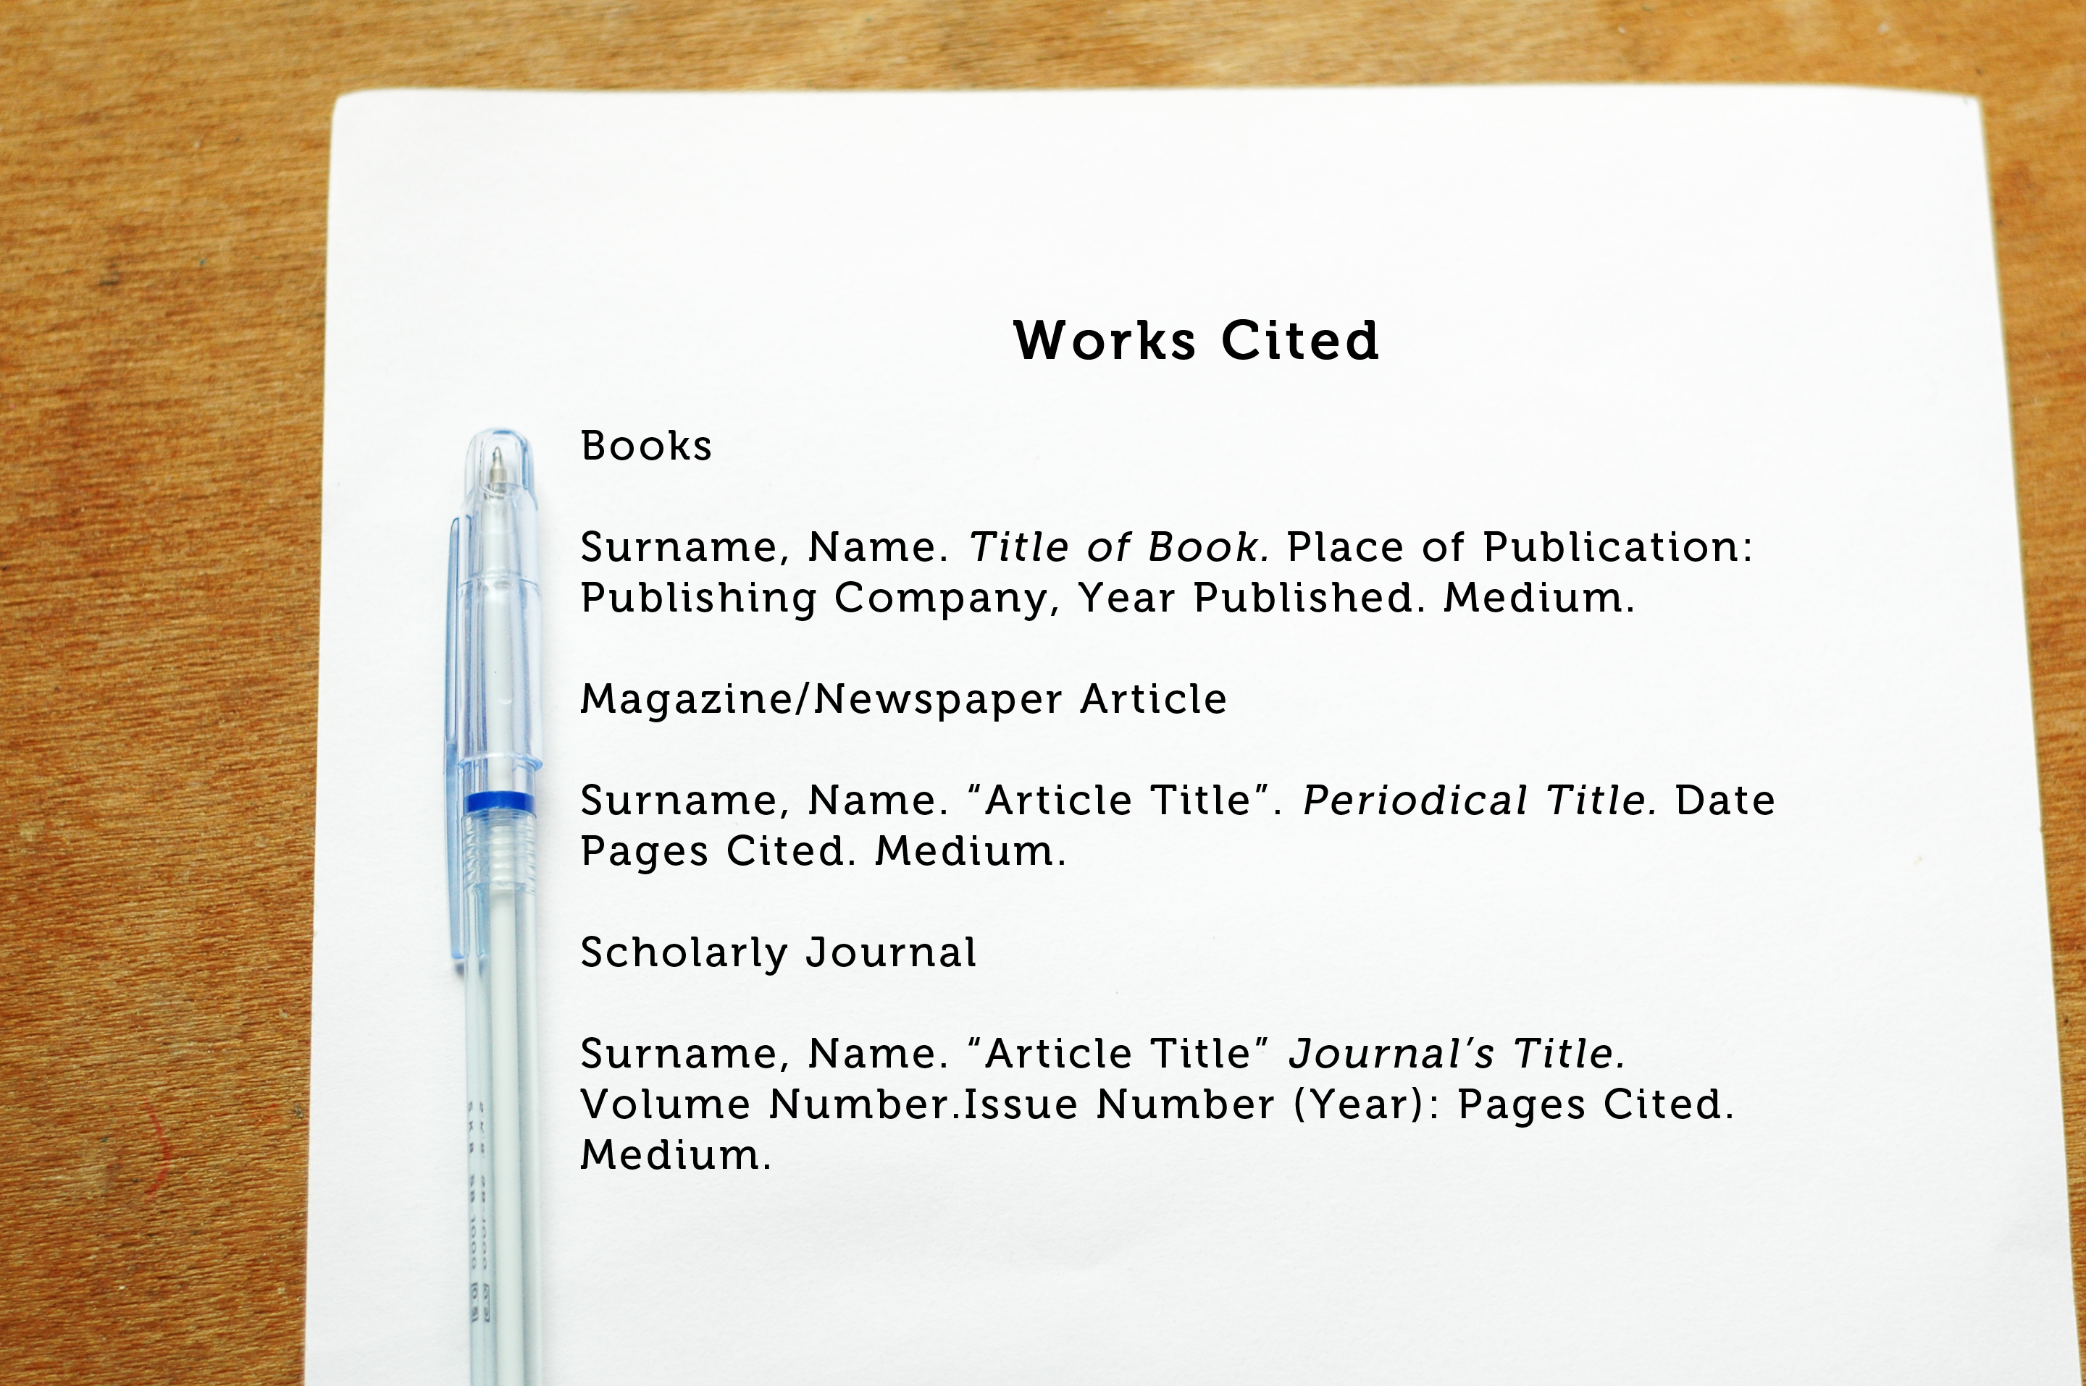

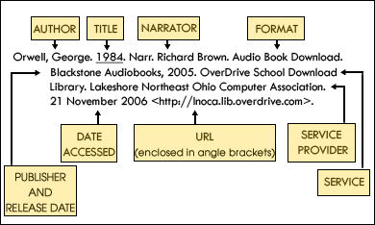

ALWAYS WRITE IN THE SAME FONT!
Your professor’s will give you the font that they want you to use. Usually, 12 pt Times New Roman.

