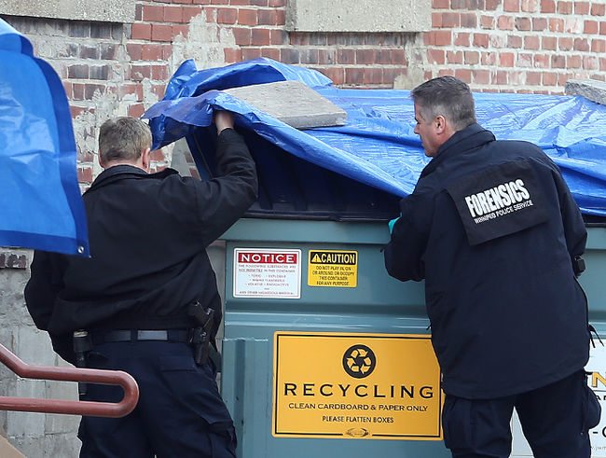

Creating Headlines
“You have to find the heart of a piece.” (The Shipping News)
Creating a headline usually focuses on one of 4 elements: humor, fear, intrigue (secrets) or fact.
Look online for 4 pictures that you can uses a photo for a cover story. Then create a headline for each: 1 humor, 1 fear, 1 intrigue, 1 fact.

