Breads and Culture
The Hungarians have a saying that "bread is older than man".
More than 12,000 years ago, primitive people made flat breads by mixing flour and water and placing these "cakes" in the sun to bake. Later, bread was baked on heated rocks or in the hot ashes of a fire. It was the Egyptians who are credited with using a "starter" of wild yeast that was present in the air; it was kept and mixed with other dough and baked to create a leavened product. Legend has it that a slave in a royal Egyptian household forgot about some dough he had set aside. When he returned, it had doubled in size. Trying to hide the mistake, the dough was punched down furiously and baked. The result was a lighter bread than anyone had ever tasted.
The ancient Greeks had over 50 kinds of bread. Public bakeries and ovens were built by the government for everyone's use and were popular places to visit the neighbors.The Romans continued the idea of the public bakery. They also required that every baker put an identification stamp on the loaves. In the Roman times, grain was ground with millstones and the finest flour was sifted through silk sheets!
Like people, breads have regional and national characteristics. Because of the climate, soil and other conditions, different grains grow better in certain regions of the world. The type of flour(s) readily available, the shape of the loaf, its seasonings and decoration often denote the bread's culture and country, and many times even its baker.
North America is a diverse agricultural country. Wheat, barley, corn, rice and many other grains are grown. How much depends upon the weather, the market for grain products and on other factors such as crop rotation and irrigation. We are also a diverse country in terms of its people. Most of our ancestors were from other countries and may have passed down recipes, stories, and food preparation techniques.
Activity: Using a map of the North America plot where grains are grown and taste some breads that are popular in various regions. If you travel to an area of our country or to another country, be sure to find a bakery and try something new to you. In Switzerland or Germany a gilt pretzel hanging over a door designates the establishment as a bakery! Remember that as you go to new places, items with similar names might taste quite different.
Yet, foods are remarkably similar. A Russian blini, Norwegian lefse, a French crepe, and a Mexican tortilla are all like the American pancake. Except maybe a different flour or preparation technique was used. In Japan, rice and won tons are popular, but so is bread! In fact, there may be more types of bread in Japan than in the U. S. Often, it is about 1 1/2 times the thickness of sliced bread in our country.
You probably won't find standard, rather spongy commercial white bread in most other countries. However, many countries still value white flour as it produces a lighter product and is expensive to process. It is interesting that simple basic dark loaves of bread may be considered peasant food in one part of the world, while elsewhere, they are found only on sophisticated gourmet tables.
The language of the country or region has a lot to do with our philosophy about bread and many other subjects. In American English, the words "bread" and "dough" are slang for money. A "bread winner" is a person who earns money to keep their family going and a "bread basket" often refers to a geographical region that has a principle grain supply. Have you ever thought about our expression, "the greatest thing since sliced bread?
In Arabia, the words for "bread" and "life" are almost the same. The Russian word for hospitality translates into "bread and salt". In Russia, it is a custom and a sign of honor and respect to give a round, freshly baked loaf of bread to a guest along with a small wooden bowl of salt during their greeting.
As you study the language and culture of other countries, you'll find other words, phrases and philosophies about bread.In all countries, bread closely coincides with religion, seasonal and national events. In the bible alone, there are approximately 250 references to bread. Philosophy, religion, and legend also play a definite part in the history of bread making. Some breads are named for their region or because of their shape. Calzone is said to mean "pants leg" probably because of its resemblance to the billowy trouser legs favored by Neopolitan men in the 18th and 19th centuries.

Giving bread has always been a sign of friendship, particularly when it is for a sick or bereaved person. Yeast and sourdough strains are very valuable and their "disappearance" are often the substance of which good mystery stories are written. For most of the world, bread is the staff of life. Today, bread is probably eaten in more places and in greater amounts than any other food. Both leavened and unleavened breads are popular. Many households consume at least a loaf of bread with each meal.

Discussion: Ask the students to tell something about the heritage of their family. If they don't know, ask them to talk with family members about this and to return with a recipe that is
1) handed down through at least one generation
2) one that the family has enjoyed for a long time.
Ask young people to bring a story, a recipe for a bread, or a practice from another land. Encourage the students to try recipes from other places and to learn to enjoy new tastes and experiences.

Best 1 Hour Bread

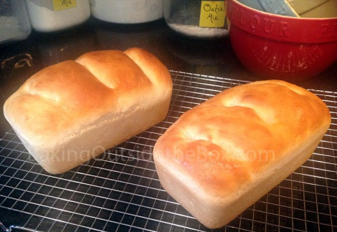
Print
Simply delicious bread. Easy to slice. It's moist, chewy and great for sandwiches. Wonderful slathered with honey and butter straight out of the oven.
Author: Laura Hickman
Recipe type: bread
Cuisine: American
Serves: 2 loaves
Ingredients
- 5 ½ cups flour
- 2 T. yeast
- ¼ cup sugar
- 4 tsps. salt
- 2 ½ cups warm water (not too hot and not tepid)
- 2 T. olive oil
Instructions
- Grease two bread pans. (Glass or ceramic preferred.)
- Combine the dry ingredients in mixer using dough hooks for a few seconds on low.
- With mixer on low, slowly pour in warm water and olive oil.
- After ingredients are combined, turn mixer speed to medium.
- Mix for 5 minutes on medium. Dough should mix together and come away cleanly from the sides of the bowl during this time. Dough will be smooth at the end of mixing.
- Oil or grease hands and remover dough from bowl onto clean and lightly-floured counter or silpat and knead it 4-6 times. This is a soft dough, but if it is too sticky too handle, knead in a bit more flour.
- Divide dough evenly into two balls and shape into loaves and place in prepared pans.
- Lightly cover loaves with plastic wrap or clean dish towel and sit in a warm place to rise till dough is about double in volume up to 30 minutes.
- While dough is rising, heat oven to 400°.
- Bake loaves for 15-20 minutes, till golden brown. Turn them out onto cooling rack. (And of course while it will slice better when it cools, it is irresistible when warm out of the oven, dripping with butter and honey. Enjoy.)
Notes
Baker’s Secrets: To make the crust pliable and the bread easier to slice after it cools, brush a tiny bit of butter over the loaf tops when they first come out of the oven.
Variations: Cinnamon bread: Heavily grease two pans. After kneading, pat and spread each dough ball on floured surface into a rectangle shape about 7” x 10”. Stir together ½ cup brown sugar and 2 tsp. cinnamon. Divide and spread 1 T. butter on rectangles. Sprinkle cinnamon mixture evenly over rectangles, leaving about an inch on one end (7” side) plain. Roll up dough firmly toward plain end. Pull plain end over dough and press to seal. Gently pull open sides toward seam and place seam side down in pan. Bake as directed.
Artisan Bread: This is sooo good! Grease a large cookie sheet and dust with a small amount of cornmeal. Shape loaves into rounds or elongate them to look like French bread. Deeply slash the loaves (I use kitchen shears). Sprinkle with a bit more cornmeal over the top for authenticity if you like and allow them to rise. Place a cake pan with about 2” of hot water into oven and heat oven to 450° while loaves are rising. Bake 20-30 minutes till crust is deeply golden. (Do not butter the top.)
Nutrition Information

Ciabatta (Italian Slipper Bread)
READY IN: 16hrs 20mins

23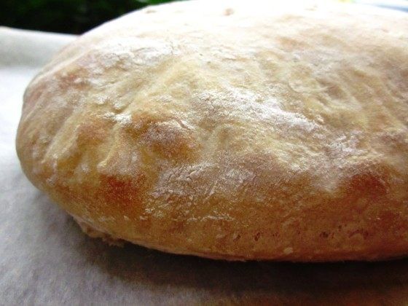

For Sponge
- ¹⁄₈teaspoon active dry yeast
- 2tablespoons water (105-115 F)
- ¹⁄₃cup room-temp water
- 1cup bread flour
- For Bread
- ¹⁄₂teaspoon active dry yeast
- 2tablespoons warm milk (105-115 F)
- ²⁄₃cup room-temp water
- 1tablespoon olive oil
- 2cups bread flour
- 1 ¹⁄₂teaspoons salt

Directions
- Make sponge: Stir together, warm water and yeast.
- Let stand 5 minutes, until creamy.
- Transfer yeast mixture to another bowl and add room-temp water and flour.
- Stir for 4 minutes.
- Cover bowl with plastic wrap.
- Let stand at cool room temp at least 12 hours and up to 1 day.
- Make bread: Stir together yeast and milk in small bowl and let stand 5 minutes, until creamy.
- In bowl of standing electric mixer, with dough hook, blend together milk mixture, sponge, water, oil and flour at low speed until flour is moistened.
- Beat on medium for 3 minutes.
- Add salt and beat for 4 more minutes.
- Scrape dough into oiled bowl and cover with plastic wrap, until doubled- about 1 1/2 hours.
- Note: Dough will be VERY sticky and full of bubbles.
- Cut two pieces of parchment paper, approx 12 inches by 6 inches.
- Place on baking sheet and flour well.
- Turn dough out onto a well-floured surface and cut in half.
- Transfer each half to paper and form irregular ovals approx 9 inches long.
- Dip fingers in flour and dimple loaves.
- Dust tops with flour.
- Cover with dampened kitchen towel and let rise 1 1/2 to 2 hours, until almost doubled.
- At least 45 minutes before baking bread, pre-heat pizza stone on lowest oven rack position at 425°F.
- Transfer 1 loaf, along with parchment paper, onto stone and bake for 20 minutes or until pale golden.
- Remove to cooling racks and repeat with second loaf.

